HOLIDAY FORM
Weaverthorpe
Pre-School Centre

NAME: ………………………………………………………........

DATE OF HOLIDAY:

FROM: ………………………………...... TO:………………………………………........

I request the above leave of absence from Pre-School to go away on holiday

……………………………………………………………….. …………………………………..
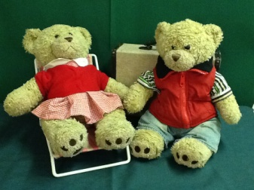
Signed Date

Please return this completed form back to Pre-School

Murray and Mabel bear, our Pre-school mascots, enjoy going on adventures.

If available, I would like to take Murray/Mabel (delete as appropriate) on holiday

